**Experimental Analysis of Gas Turbine Performance**

Christopher R. White

MWG: David Bedding, Jorge Godoy, Samuel Hordeski, Kevin Myers, Justin Sandler

Department of Mechanical Engineering

Lafayette College

Easton, PA 18042

**Abstract**

Currently airplanes operate premierely on gas turbine engines as propulsion systems to generae thrust by tranfering thermal energy into a working gas in order to extact mechanical work via turbine. Since gas engines produce useful thrust over a limited range of crankshaft rotational speeds, aircraft operate at different altitudes, therefore certain rpm ranges increase performance, whethere taking off, landing, or high altitude flight. **Since gas tubine engines perform optimally at certian rotational speeds, manufacturers want to increase engine performance in order to get optimal efficiency at certain altitudes.** The purpose of this experiment was to determine the optimal shaft rotation speed ranges to achieve the maximum engine efficiency for a SR-30 Minilab gas turbine engine. Pressure, temperature, shaft rotational speed, fuel flow, and thrust were measured for the cases between idle and full throttles, resulting in the following rotational speeds of 42,493 to 77,067 RPM in order to explore the effect of rotational speed on performance. The performance of the cycle will be characterized through the specific thrust, thrust specific fuel consumption, cycle efficiency, power match, propulsive efficiency, and combustor efficiency. This will be compared to the theroretical gas turbine performance: theoretical thrust, theoretical specific thrust and thrust specific fuel consumption.**The experimental performance of the engine was evaluated based on the torque and power curves and the results were compared to published data from manufacturer [3]. The low throttle case achieved an optimal mechanical efficiency of 65.0±1.73% at 1200 RPM. The middle throttle had the highest mechanical efficiency of 79.5±0.83% at 1830 RPM. The full throttle case achieved an efficiency of 81.8±1.13% at 1770 RPM.**

**Introduction and Methods**

According to the National Oceanic and Atmospheric Andministration, there are more than 87,000 flights across the skies in the United states, with air traffic controllers handling apprixmately 64 million takeoffs and landings every year [http://sos.noaa.gov/Datasets/dataset.php?id=44]. In order to transport these people and cargo to their intended destinations, planes rely on gas turbine engines in a variety of forms such as turbojets, turbofans, and turbo props. Gas turbines are compact, lightweight, and reliable heat enginese that are capable of producing a wide range of power from several hundread kilowatts to hundreds of megawatts [brayton.pdf].These engines can be analyzed and all of which have the four main components: compressor, combustion chamber, turbine, and nozzle. The thermodynamics of all gas turbines are similar and can be modeled using the idealized Brayton cycle with no internal irreverabilies. The schematic and the T-s diagram of the Brayton cycle are illustrated in Figure 1 that can be analyzed using the steady-flow energy equation, expressed as

${(q}_{in}-q_{out})-{(w}_{in}-w_{out})= h_{e}-h_{i}$ (kJ/kg) ⑴

where $q$ is heat transfer and $w$ is the work, and $h$ is the enthalpy at the exit and inlet of the control volume. These components can be analyzed under the assumption that they are steady-flow devices, the working fluid is air behaving as a perfect gas, negligible friction and the compression and expansion processes are reversiable and isentropic

The ideal Brayton cycle is illustrated in Figure 1 begins with process 1-2 as air is drawn into compressor, resulting in an increase in pressure isentropically. Heat is transferred isobarically in process 2-3 as the compressed air flows in combution chamber via combustion of fuel through. The expanding heated air isentropic air in process 3-4 as it flows across turbine blades transfering thermal energy into work in the form of kinematic energy to rotate the blades and drives an output shaft attached to the compressor to drive the compressor as the gas expands. From process 4-5 the ehaust enters the nozzle which reduces the cross sectional area providing thrust isentropically. Heat is rejected isobarically in process 5-1 as the exhaust gas enters the environment.

Due to irreverabilities, The performance of each of the components the compressor, turbine, and nozzle is evaluated through the efficiencies expressed as

$$η_{comp}= \frac{h_{0_{2_{s}}}-h_{0_{1}}}{h_{0_{2}}-h_{0_{2}}}$$

$$η_{turb}= \frac{h_{0_{4}}-h_{0_{3}}}{h_{0_{4_{s}}}-h_{0_{3}}}$$

$$η_{nozz}= \frac{h_{0_{4}}-h_{5}}{h_{0_{4}}-h_{5_{s}}}$$

The overall pefromance of the thermodynacmic gas turbine engine cycle can be analyzed using the following characteristics. Specific thrust is an indication of the engine efficiency as the ratio between the engine thrust and the mass of the air expressed as

$$T_{S}= \frac{Thrust}{{\dot{m}}_{air}}$$

Thrust specific fuel consumption describes the fuel efficiency of the engine through the fuel flow rate relative to the engine thrust output expressed as

$$TSFC= \frac{{\dot{m}}_{fuel}}{Thrust}$$

Cycle efficiency is the overall efficiency of the brayton cycle as a ratio of the heat lost to the heat transferred into the system expressed as

$$η_{cycle}=1- \frac{h_{0_{5}}-h_{0_{1}}}{h_{0_{3}}-h_{0_{2}}}$$

Power match???

$$PM= \frac{{({\dot{m}}_{air}-{\dot{m}}_{fuel})(h}_{0_{5}}-h_{0_{1}})}{h_{0_{3}}-h_{0_{2}}}$$

Where PM would be equal for isentropic compressor and turbine combination

Propulsive efficiency is the efficiency at which the energy contained within the fuel is converted to useful energy in order to account for the losses due to aerodynamic drag, gravity, and accelerated. It is the proportion of mechanical energy actually used to propel the aircraft expressed as

$$η_{prop}= \frac{Thrust × V_{1}}{{({\dot{m}}_{air}-{\dot{m}}_{fuel})(h}_{0_{5}}-h_{5})-{\dot{m}}_{air}(h_{0_{1}}-h_{1})}$$

Combustor efficiecny

$$η_{comb}= \frac{(1+f)h_{0_{3}}-h_{0_{2}}}{fQ_{Jet A}}$$

In the current study, gas turbine engine ___________ was experimentally determined for idle, low, middle, and full throttles. The actual cycle was compared to the idealized Brayton cycle in order to validate the experimental process.

The experiments were performed on an instrumented SR-30 Minilab gas turbine engine. Pressure, temperature, shaft rotational speed, fuel flow, and thrust were measured for rotational speeds between 42,493 and 77,067 RPM. The experimental schematic and locations of the instrumentation are illustrated in Figure 2.

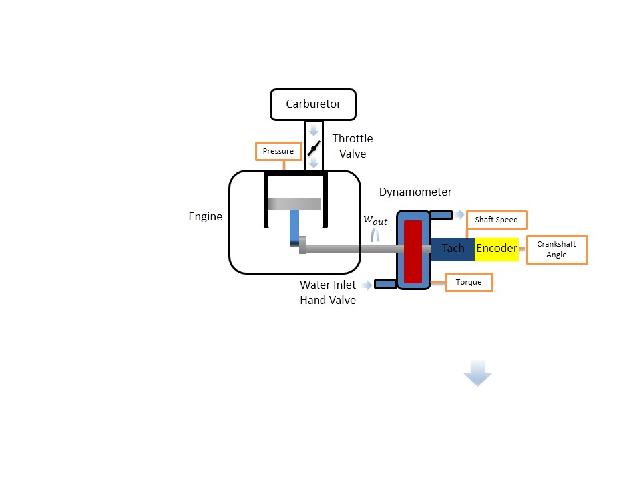**Results and Discussion**

**Figure 2: Experimental Four-Stroke Engine Schematic with Instrumentation Locations: AutoPSI Pressure Sensor, Strain Gauge for Torque, Tachometer for Shaft Rotational Speed, and Optical Encoder for Crankshaft Angle [White C.]**

The following experiments were considered: (1)idle, (2) low throttle, (3) middle throttle, and (3) full throttle.

The operation of the Briggs & Stratton V-Twin OHV 16 was initiated according to startup procedure in the Operating Instructions at a laboratory temperature of 75.2˚F and barometric pressure of 14.7 psi[3]. For each throttle case, the butterfly valve was adjusted to the corresponding throttle position, where it remained for the duration of the loadings. The range of loadings on the output shaft was controlled via water flow rate, adjusted gradually from 0 to 10 GPM via the D-100 Small Engine Dynamometer in order to observe the variation in engine mechanical efficiency between low to high output shaft speed. Crankshaft angle, torque, shaft speed, and pressure were recorded for approximately 50 loadings for each throttle case at the locations illustrated in Figure 2. P-V diagrams for each throttle case were generated actual four-stroke cycles in Figure 3. The engine efficiencies for the low, middle, or high throttle were determine for each case using Eq. (3) and are displayed in Figure 4a. Error in torque and power was sensor calibration, evaluated standard deviation based on variation in measurements in order to determine uncertainty at 95% confidence.

The P-V curves for each throttle case are displayed in Figure 3a at approximately the middle loading. The pressure in the engine during combustion increases in respect to throttle, resulting in an increase in the work generated during the power stroke process. The exhaust/intake pump work region remains consistent regardless of throttle position, since these processes occur isobarically, therefore there are no differences between the pump work region across throttle cases. The compression stroke is for the low throttle occurs at a lower range of pressures compared to the higher throttles due to the higher stored kinetic energy in crankshaft at higher rotational speeds. The relationship between crank angle and combustion timing is critical because combustion is optimal for torque output at an angle the maximum pressure should occur a few degrees past 0˚ in order to create the maximum torque whereas at 0˚, no rotational torque would be transferred into the output shaft.

Figure 3b shows that mechanical increases with loading, with a mechanical efficiency of 0 at no loading, since no usable work is being outputted from the engine. When a loading is applied to the output shaft, the engine is transmitting power out of the engine in order to drive the shaft to rotate under the loading. As the loading increases, the rotational speed decreases and the amount of useful power produced increases. Mechanical efficiency for the middle and full throttle cases peaks at approximately between 75 and 80%. The mechanical efficiency error was below 0.13, indicating that the error was insignificant in affecting the result.

**Figure 3: (a) P-V Diagram at Middle Loading Case for Each Throttle and (b) Mechanical Efficiency vs Speed**

**Figure 4: Low, Middle, and Full Throttle (a) Torque, (b) Power, (c) and Power with Briggs & Stratton Curve Fit Error, (d) Gross Power, (e) Pump Power, and (f) Overall Power for Experimental and Otto Cycle vs Speed**

Figure 4a displays that the torque of the low throttle case is similar to the high end torque trend found in the middle and full throttle cases. Therefore the low throttle behaves similarly and indicates that no useful torque is being produced at low throttles which means the working fluid is not providing enough power to the piston in order to produce power. The middle and full throttle cases have regions at lower RPM where the torque behaves linearly in a horizontal region similar to that shown in Figure 1c. Overall the results displayed that the engine produces optimally at low end torque but poorly at high end torque due to the large slope. The error was determined to be below 0.3529 for the mechanical efficiency indicats that the error was insignificant in affecting the results.

Figure 4b displays that no useful torque is being produced at low throttle, which means the working fluid is not providing enough power to the piston. The same behavior is present at high speeds for the middle and high cases. However they have regions at lower throttles where the power follows a positive slope linear region similar to that shown in Figure 1c. Power was low in this region of high RPM due to sparkplug misfiring occurring within the engine, evident in the P-V diagram variation for 3 cycles at each loading case. As a result, the fuel-air mixture is not always combusting at the optimal point to achieve the highest pressure, since the firing rate is not optimal for every speed. Power also behaves in a parabolic manner since it is related to the torque and the rotational speed and therefore acts as an energy storage device for kinetic energy. Because kinetic energy involves a squared velocity term, the power vs speed graph results in a parabolic shape. At higher RPMs, the piston has less time to fill the cylinder with fuel since the rate at which the fuel is transferred into the engine is based on the pressure gradient developed by the piston drawing in fuel. At lower speeds, there is plenty of time to fill the chamber with fuel generating more power. The error for the mechanical efficiency was determined to be below 0.2152, indicating that the error was insignificant in affecting the results.

Figure 4c displays the experimental power vs rotational speed of the shaft compared to the published data by Briggs & Stratton [3]. The cosample deviation was determined between each load case and the published data. The published data lies within the bounds of the error bars between the tested ranges of 1250 to 3250 RPM. The published data is similar to the idealized curve in Figure 1c and visually does not display a significant decrease in power at high rotational speeds. Since the performance displays that the engine operates optimally at very high RPMs, this indicates that there is no misfiring. Based on the published data, it can be concluded that Briggs & Stratton adjusted the firing rate for each loading so that the engine data would display a 2nd order polynomial trend in power.

Figure 4d displays the experimental gross power vs the rotational speed of the output shaft. At high RPMs approximately 3500 RPM for full throttle and 2750 RPM for middle throttle the gross power increases rapidly until it peaks, after the peak, the curve decreases slowly. The low throttle case is an example of data is in a region of low torque and RPM which makes it does not lend itself to be applicable for the trend since it was sampled below the threshold of 1700 RPM.

Figure 4e displays the experimental pump power vs the rotational speed of the output shaft. According to the diagram, the pump work increases as the rotational speed increases, due to the increase in intake and exhaust mass flow rate of the fuel-air mixture. Initially it is negative for high RPM, because it requires more work to intake and exhaust the mass of fuel-air mixture. One the engine slows to a slower rate, there is more time for the fuel to be injected into the cylinders and therefore more fuel consumed during the combustion process resulting in more work generated during the power stroke.

Figure 4f displays the power vs the rotational speed of the output shaft compared to the Otto cycle. Based on the results, the Otto cycle is significantly different compared to the experimental data. This is primarily due to the assumptions of the Otto cycle. The engine produces a heat due to the friction within the engine. Therefore due to the adiabatic, isentropic, and ideal air properties not applying to the actual system, the Otto cycle is not the ideal method of approximating engine performance.

**Conclusions**

The purpose of this experiment was characterize the performance of the SR-30 Minilab gas turbine engine at various speeds.

**References**

1. **U.S. Energy Information Administration - EIA - Independent Statistics and Analysis. (n.d.). Retrieved March 26, 2015, from http://www.eia.gov/forecasts/steo/realprices/**
2. Ҫengel, T.A. and Boles, M.A. (2002) *Thermodynamics: An Engineering Approach,* McGraw Hill, 4th Edition.
3. Rossmann, T., Sabatino, D. & Utter B. (2015). *ME 475: Gas Turbine Analysis Laboratory Description*. Easton, PA: Lafayette College.